1. 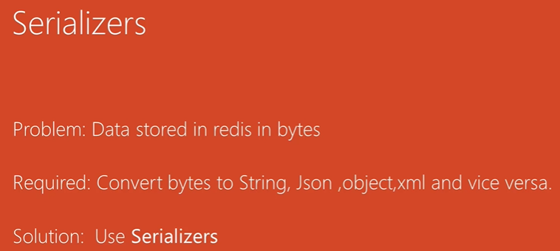
2. 5 Kinds of Serializers implemented in Spring Data.
3. 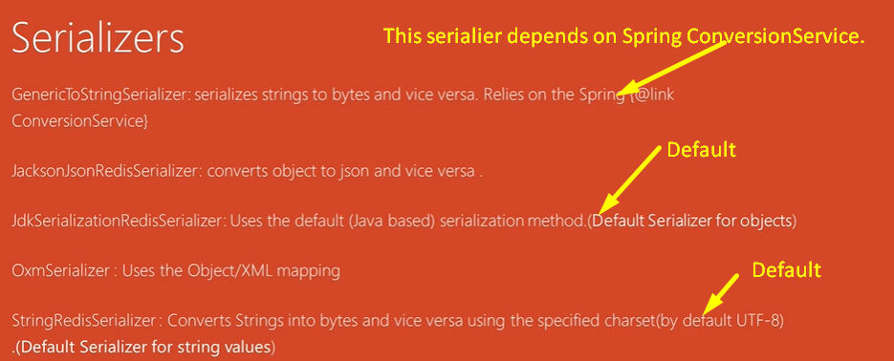
   1. GenericToStringSerializer relies on Spring ConversionService.
4. Let’s look at the Spring Data Redis Implementation for Serializer.
5. 